SUMMARY – Q4 2025
- Fidelity bought 13 shares of Seaboard stock in Q4. They hold 523 shares.

Top Buyers Top Sellers Top Holders

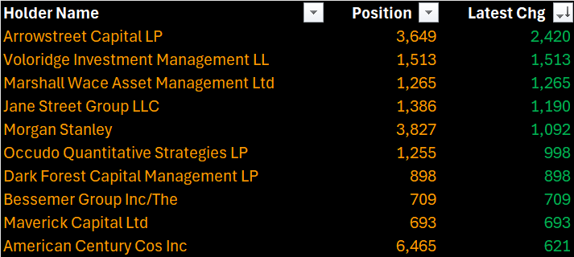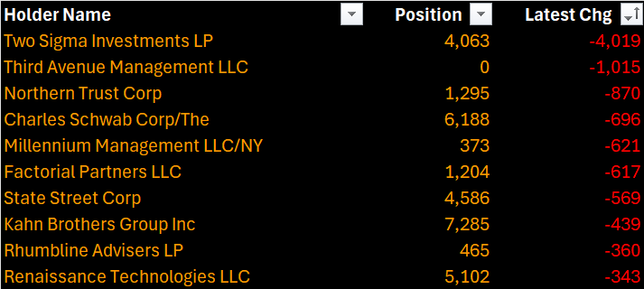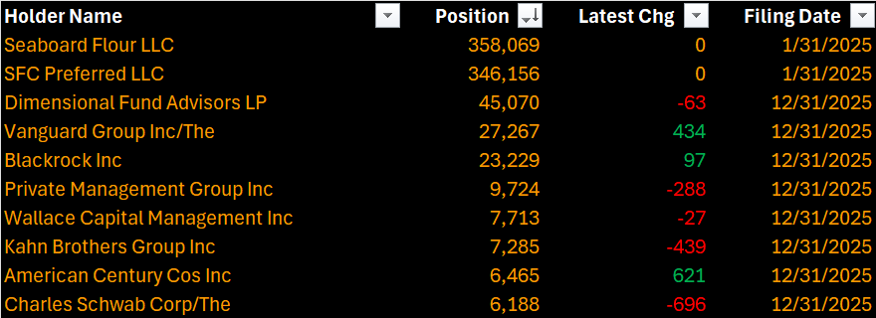
Daily Price & Volume Highest Day Volume: December 31 (19,520 shares)

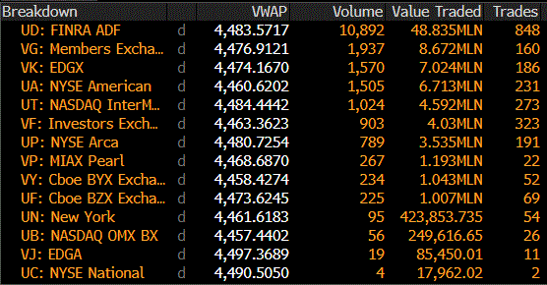
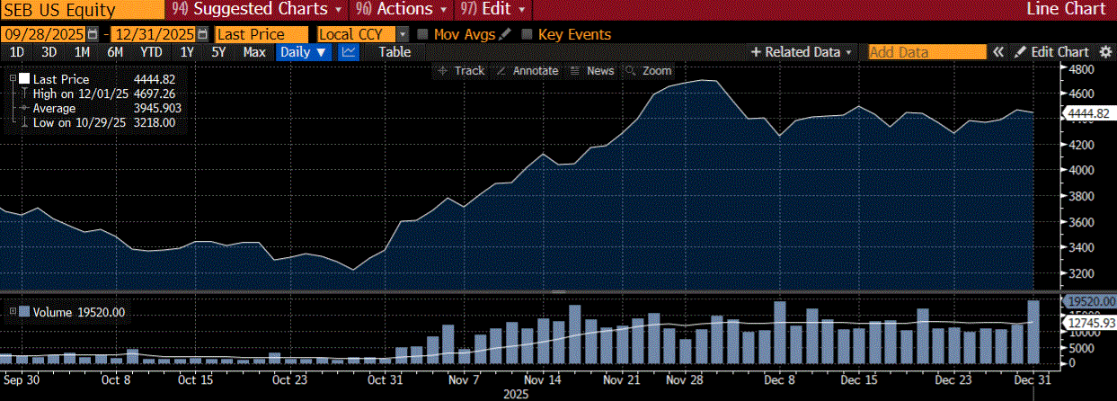

Market Commentary of December 31 volume:

On December 31, 2025, Seaboard Corporation (SEB) experienced a notable spike in trading activity, registering 19,520 shares traded, the highest volume of Q4 2025. This elevated liquidity occurred without company‑specific catalysts and is consistent with typical year‑end market behavior, including institutional portfolio rebalancing and tax‑motivated positioning. Despite the unusually high turnover, SEB’s price movement remained modest, suggesting order‑flow‑driven activity rather than a shift in fundamentals.

At the broader market level, the S&P 500 declined moderately, closing at 6,845.50, down approximately 0.74%–0.8% on the day. However, this slight pullback came against the backdrop of an exceptionally strong full‑year performance, with the index posting a ~16% annual gain—its third consecutive year of double‑digit returns. This demonstrates continued resilience in U.S. equities despite late‑year volatility and routine profit‑taking heading into calendar year‑end.

Together, SEB’s elevated year‑end volume and the S&P 500’s modest pullback fit within typical year‑closing market dynamics, driven largely by positioning adjustments rather than changes in underlying economic or company‑specific outlooks.

YTD Historical Top Holders YTD Historical Top Buyers/Sellers

